Rachel M Woo

May 18, 2021

Foundations of Programming, Python

Assignment 06

Script using Functions and Classes

# Introduction

In this module I learned how to modify a script that manages a "ToDo list." I modified a template called “Assignment06_Starter.py” that provided by the professor. The starter file loads data from a file into a Python list of dictionary objects using few *functions*. The assignment directed to add more functions to organize the code.

I also learned how to create a simple Classes, use the PyCharm debugger, and GitHub web pages. It took me few debugging to get use to how to result the error using debugger. As I figured out how to use the debugger, it got little easier. I wish I knew how to use debugger for my last assignments to results errors.

In this assignment I created a new program named “Assignment06” and added a starter template file name “Assignment06-Starter.py” from the module 6 zip folder.

In this module, I need to post my files on a public GitHub repository so that others may review it. I posed Word document and Python file similar to last assignment. Additionally, I need to add a GitHub’s webpage.

# Create a new Project and new file tasks

I created a new project “Assignment06” by right click the main folder called “PythonCLass”. Then I added template file named “Assignment06_Starter.py” provided by Professor Root. And I modified the header to add my name and dates I created code and debugged for assignment 6. Refer to Figure 1.

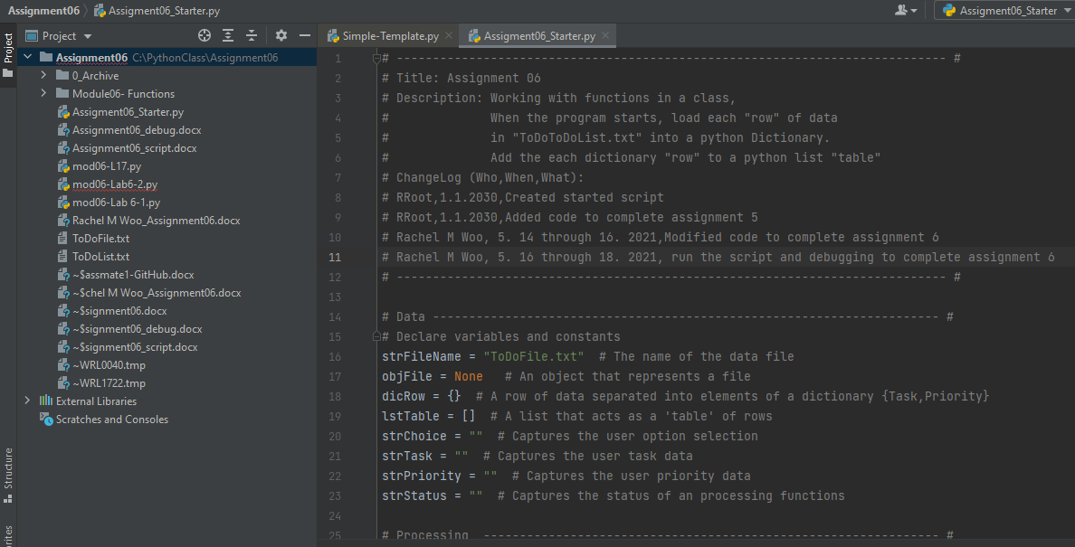

Figure 1: Added “Assignment06_Starter.py” and modified the header

# Prepping to add Code to the Script

The starter template for assignment 6 used the simple template:

1. Data – Declare variables and constant
2. Processing the data
3. Input and Out (I/O)- Presentation

Even though the starter file includes few outline of the program tasks, before I create a Python script, I outlined my *program’s task* (Pseudo code). I start by adding some basic comments about what I am going to do. This preparation helps guide me to create a Python script. The program’s task as follows:

1. Read and study the code provided
2. Add code to my script that performs the assignment’s task:
   1. Display a Menu of Options  
       1) Add a new Task  
       2) Remove an existing Task  
       3) Save Data to File   
       4) Reload Data from File  
       5) Exit Program
   2. Add scripts to perform each time user make a choice
   3. *Get a yes or no choice from the user*
   4. *Pause program and show a message before continue*
3. Debugging the code.
4. Results the error.
5. Run the program with no error.

# Adding Script

I added in Python script in PyCharm to perform program tasks *“ToDO: Add code Here!:” Refer to Figure 2 through 5 below. (Note: The added code below are after debugged and running with no error. I will provide code with errors and result with debugger)*

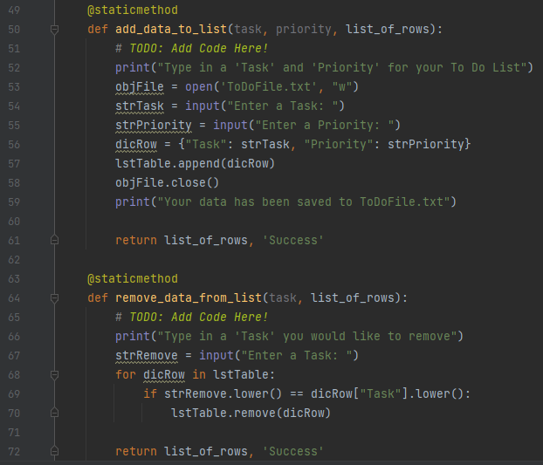

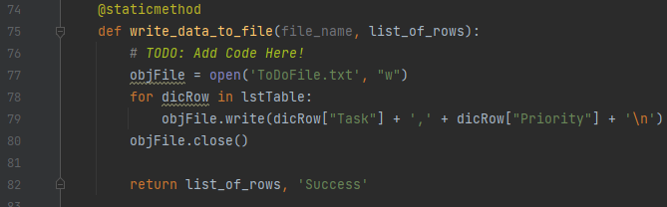

*Figure 2: TODO: Add code at line 51, 65, and 76*

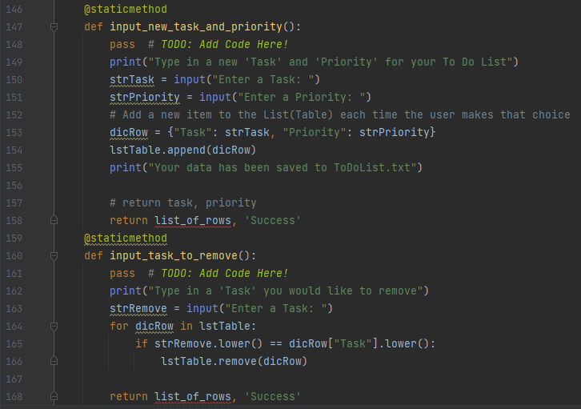

Figure 3: TODO: Add code at line 148 and 161

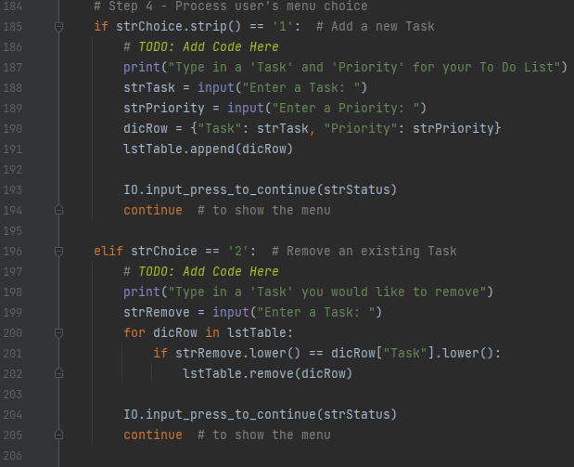

Figure 4: TODO: Add code at line 196 and 197

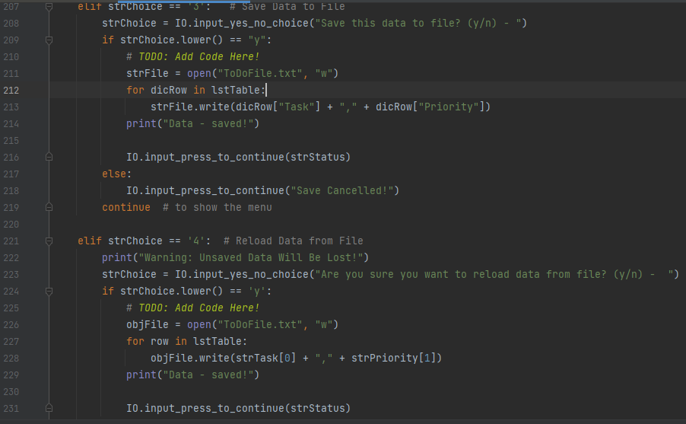

Figure 5: TODO: Add code at line 210 and 225

# **Debugging the code**

Per professor’s video and instructions, I was able to debug all my error and result the problems. Refer to figure 6 through 9 below. (Note: The reference lines may difference from the code shown in Figures 2 through 5).

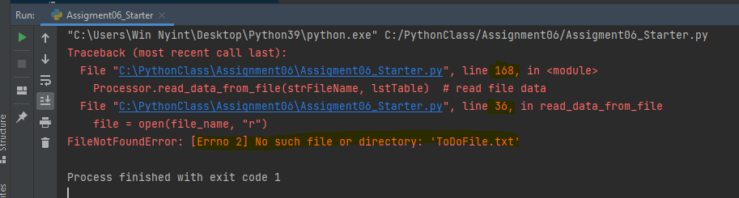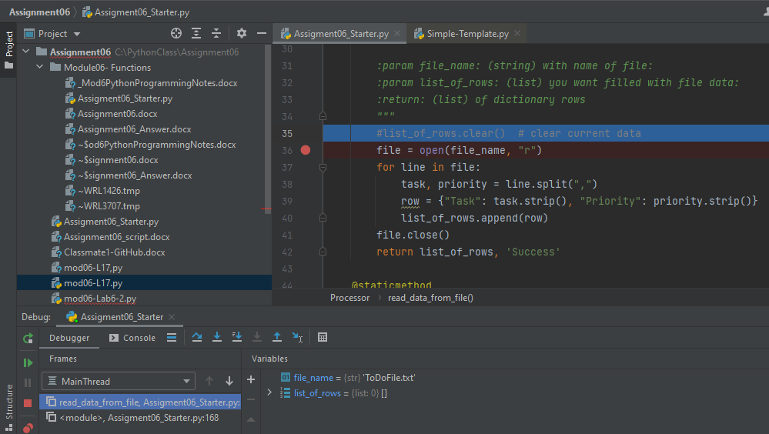

Figure 6: Run1 – error and debugging, line 36 and 168. Fix- rename the file to objFile

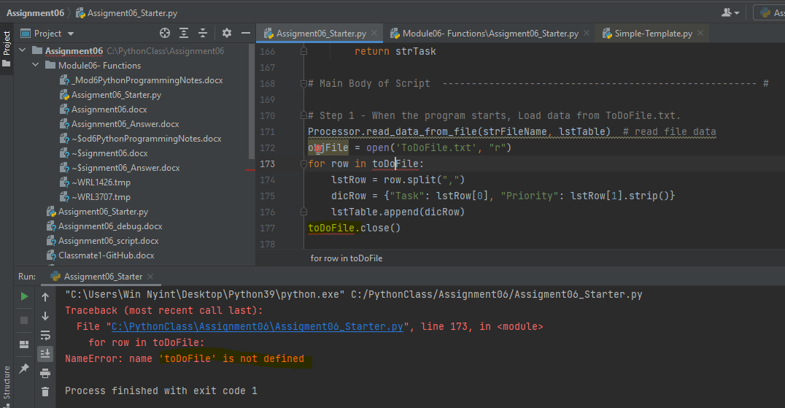

Figure 7***:*** Run2- Error- file is not defined. Debugging- correction- replace with objFile

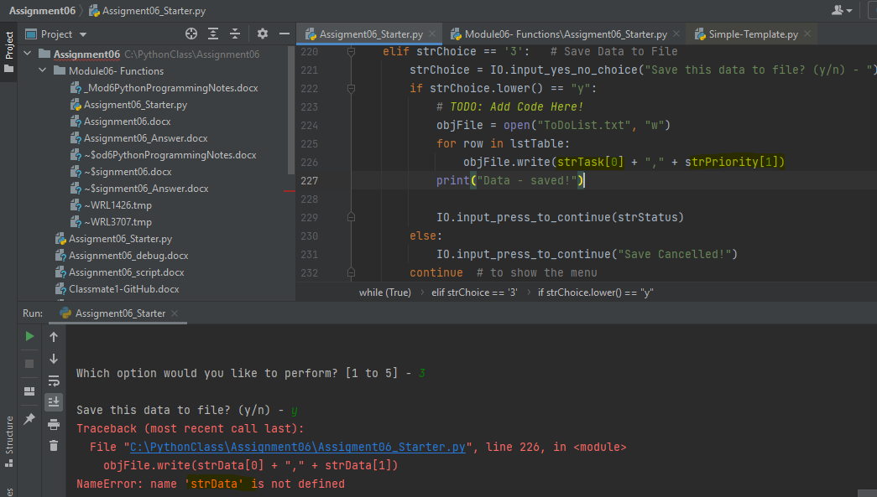

Figure 8: Run3- error and debugging change to strTask and strPriority.

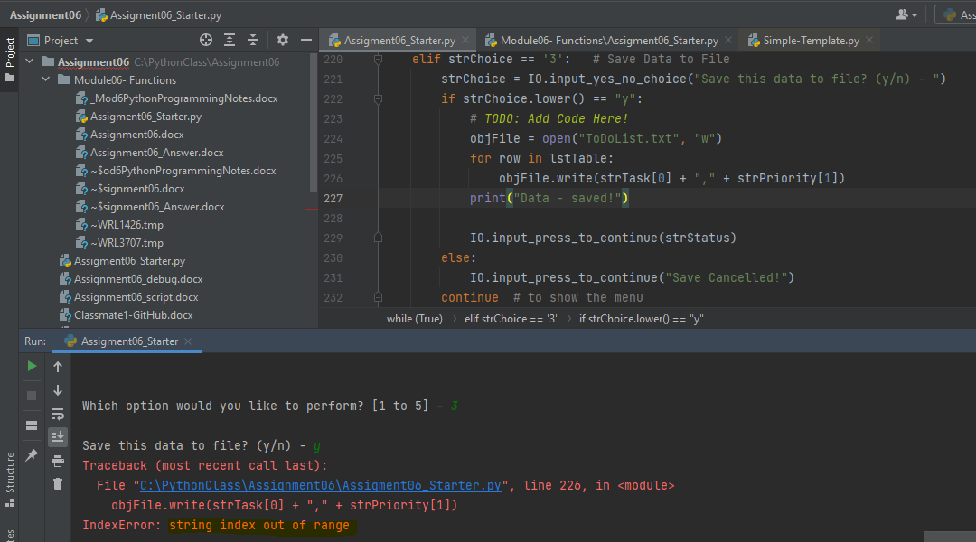

Figure 9: Run4- error and debugging, index out of range – delete extra line

## Run the Script in PyCharm and command Window

After debugging and fix the errors, now I am ready to run the script in PyCharm and an OS command/shell window. The output in PyCharm as shown in Figure 10-1 through 10-8. And the script in command window shown in Figure 11-1 and 11-2, output in Figure 12-1 through 12-4.

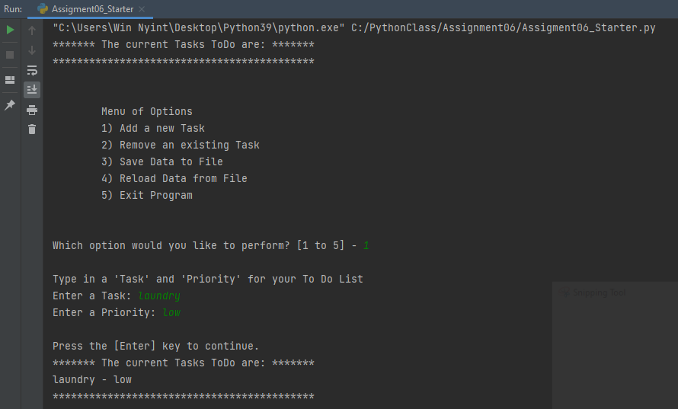

*Figure 10-1: output in PyCharm*

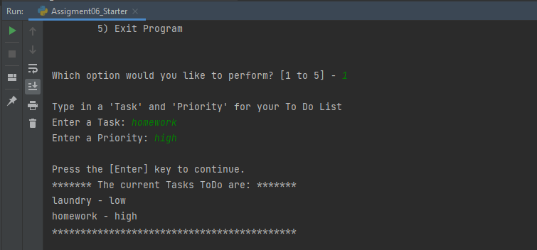

*Figure 10-2: output in PyCharm*

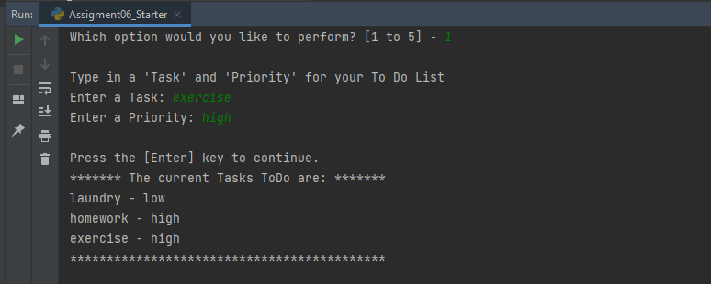

*Figure 10-3: output in PyCharm*

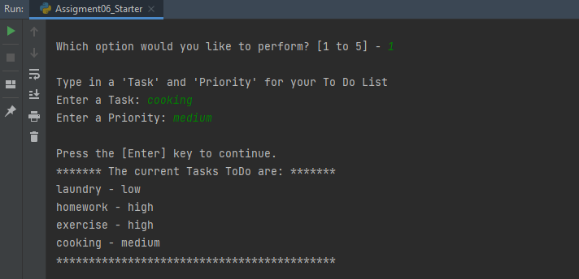

*Figure 10-4: output in PyCharm*

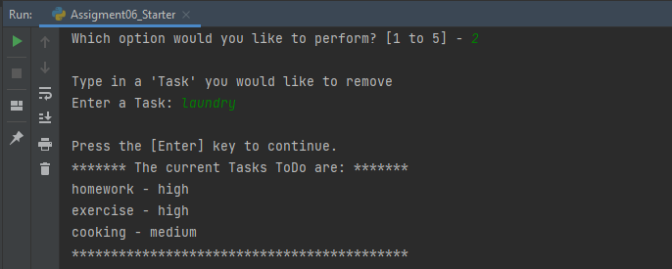

*Figure 10-5: output in PyCharm*

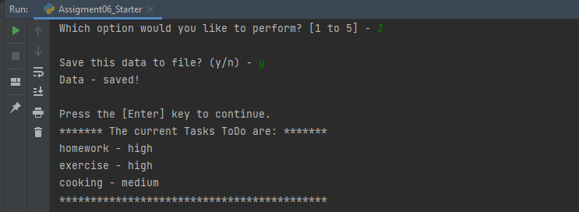

*Figure 10-6: output in PyCharm*

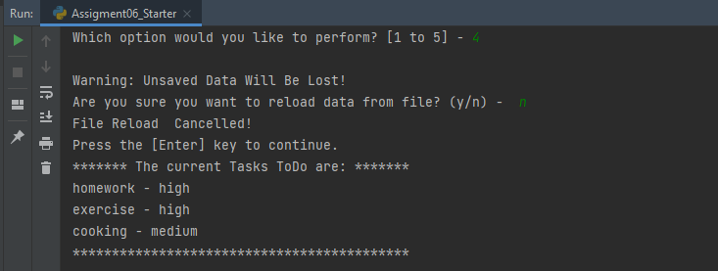

*Figure 10-7: output in PyCharm*

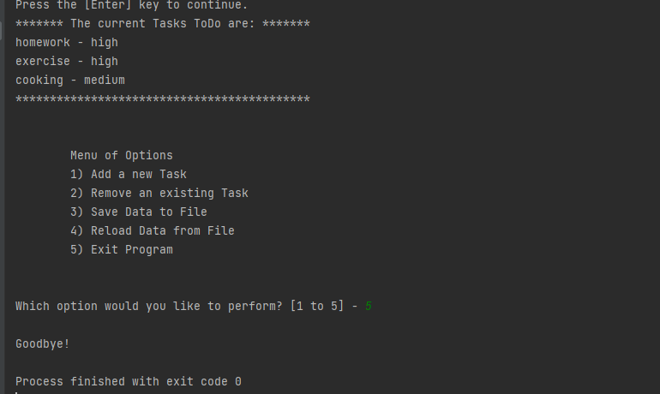

*Figure 10-8: output in PyCharm*

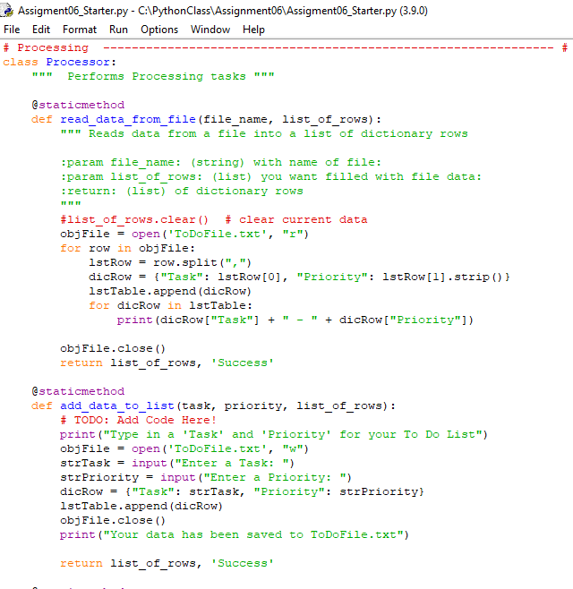

*Figure 11-1: script in Command Window*

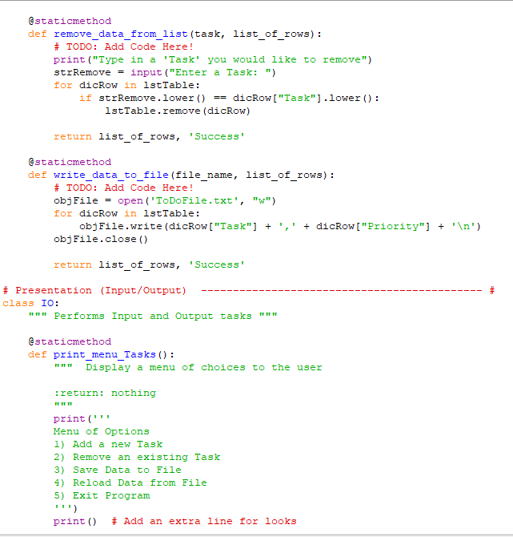

*Figure 11-2: script in Command Window and additional script not shown*

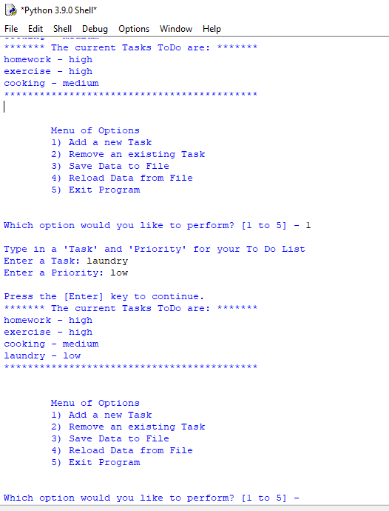

Figure 12-1: output in command window

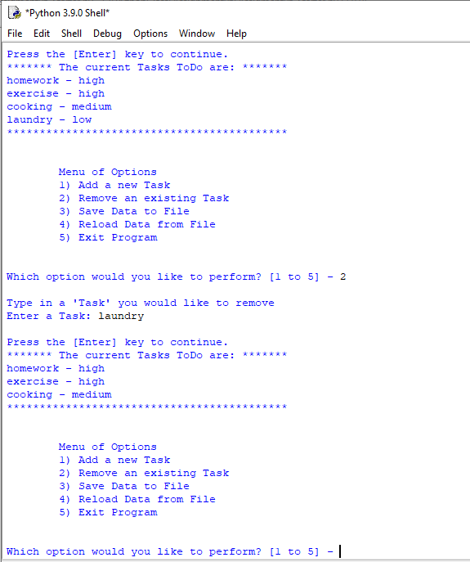

Figure 12-2: output in command window

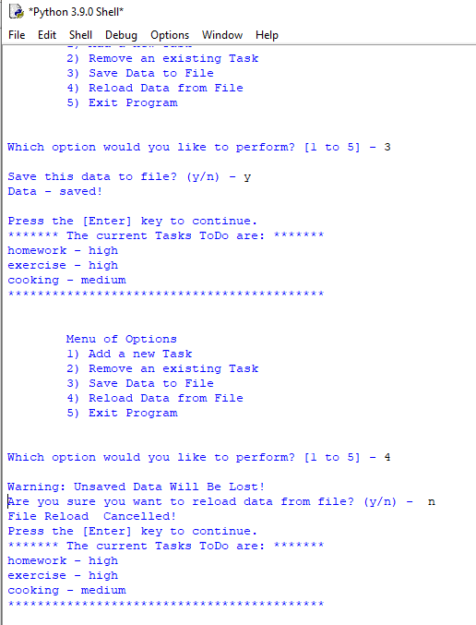

Figure 12-3: output in command window

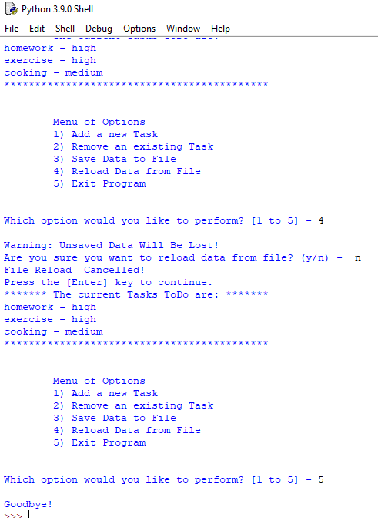

Figure 12-4: output in command window

## Creating GitHub's webpage

I created a GitHub account for assignment 5. For The assignment 6, I learned how to create a GitHub’s web. The process is like creating most web software accounts and is tied to an email account. I created a new repository named “ITFnd100-Mod06 ” as a set of shared folders where my files are stored and managed through GitHub's web server. And I configured it as public setting, so it can easily be seen and shared with other people. In order to see the repository folders materialize, I need to load assignment 6 word file and below link to GitHub’s web. (Figure 12)

 Your site is ready to be published at <https://uwrachel123.github.io/ITFnd100-Mod06/>

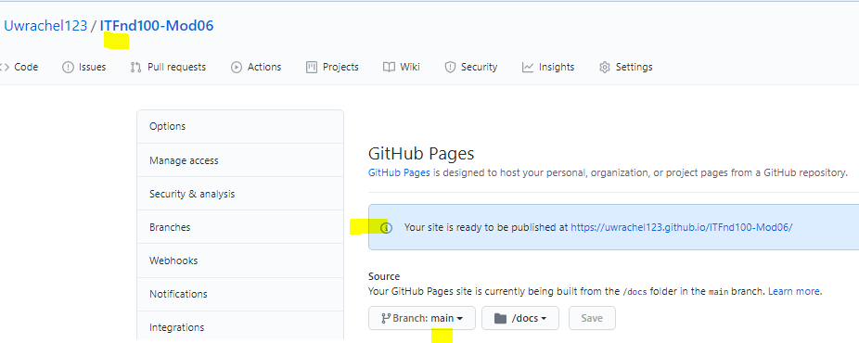

Figure 12: Created a GitHub’s web.

# Summary

Using the textbook, the Module 06 documentation and videos provided by the professor, and the supplemental websites and video, I was able to create the python code using PyCharm and run the script in PyCharm and Command window. I learned how to debug my code and help with result the errors in the script. Additionally I learned how to create GitHub’s web and utilized it to share my script and learn from my classmate’s script. The program demonstrates my knowledge of how to utilized PyCharm and run script in command window to run Python script.